CDS

CDS Functionality

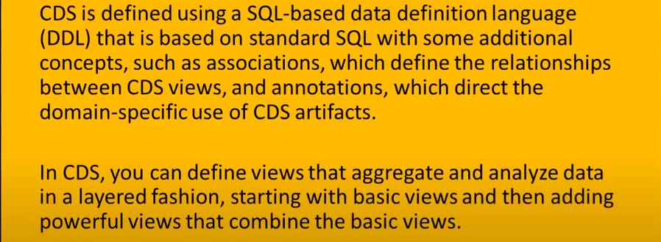

Create Package

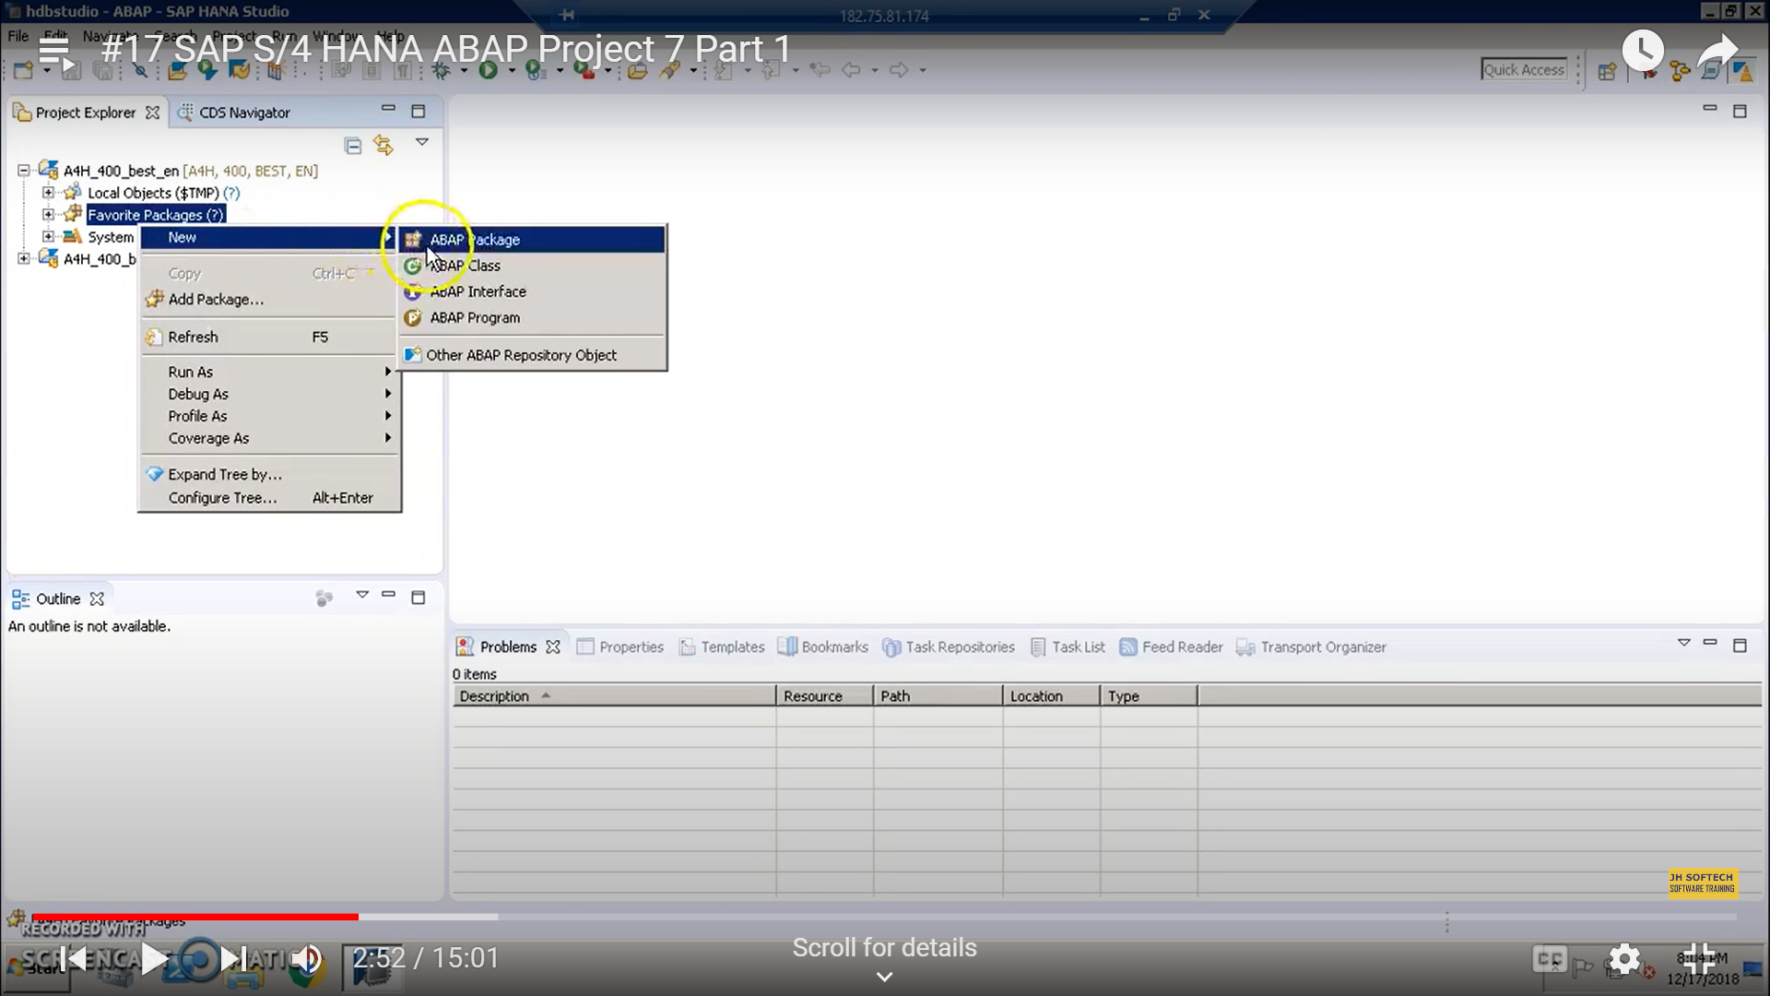

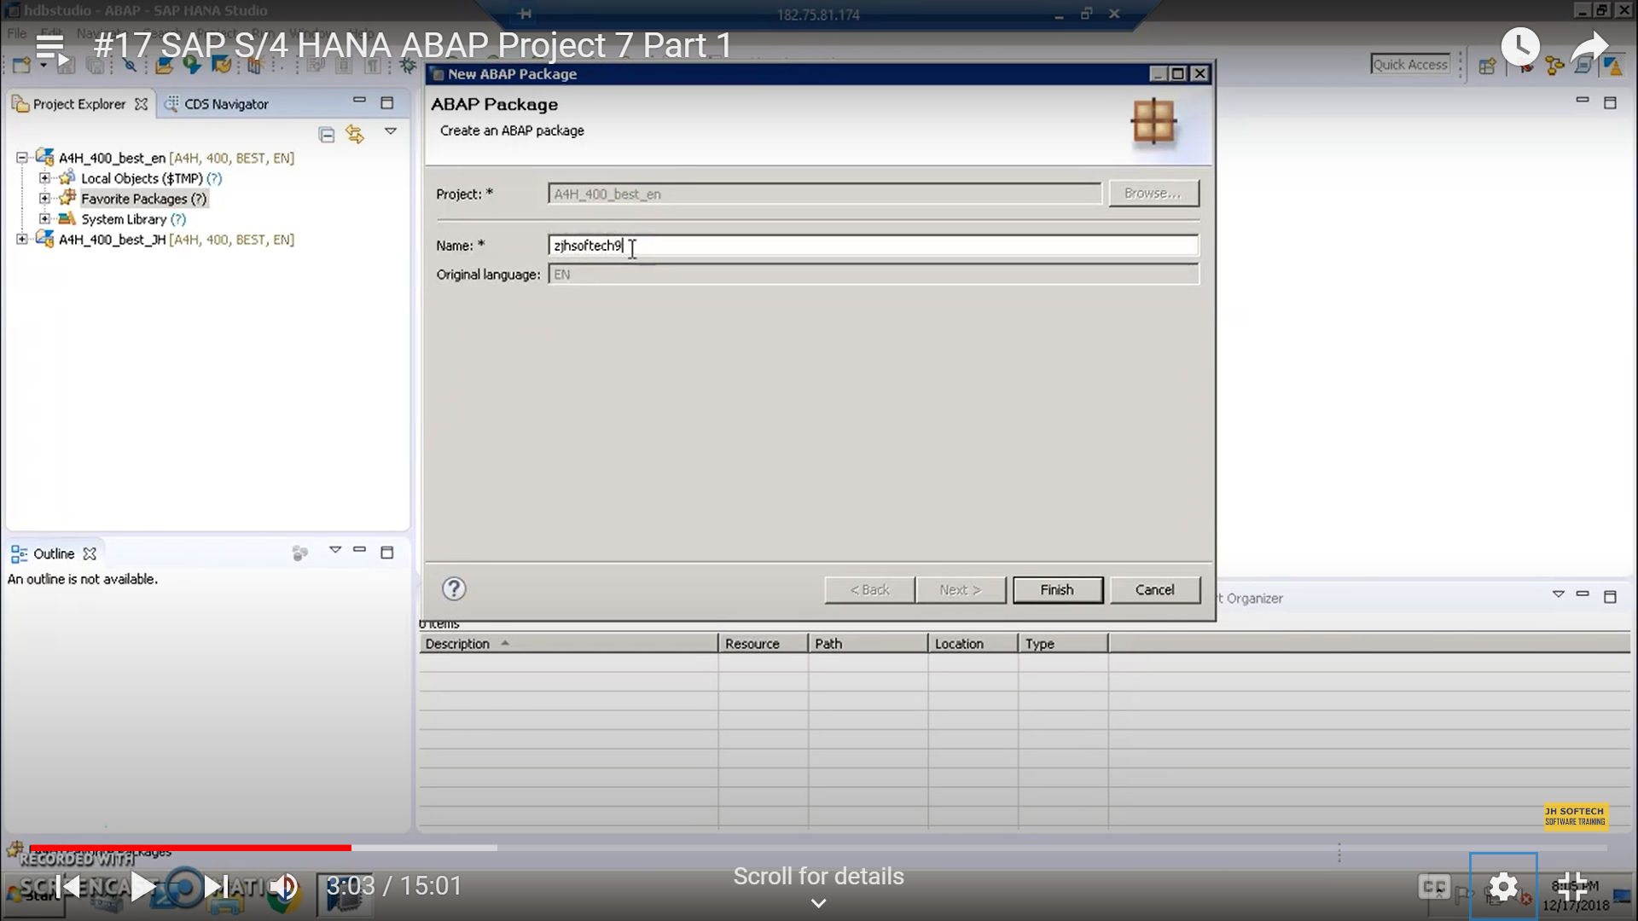

Then activate the package.

Right click

Select new ABAP repository object.

CDS -> Data Definition -> fill properties

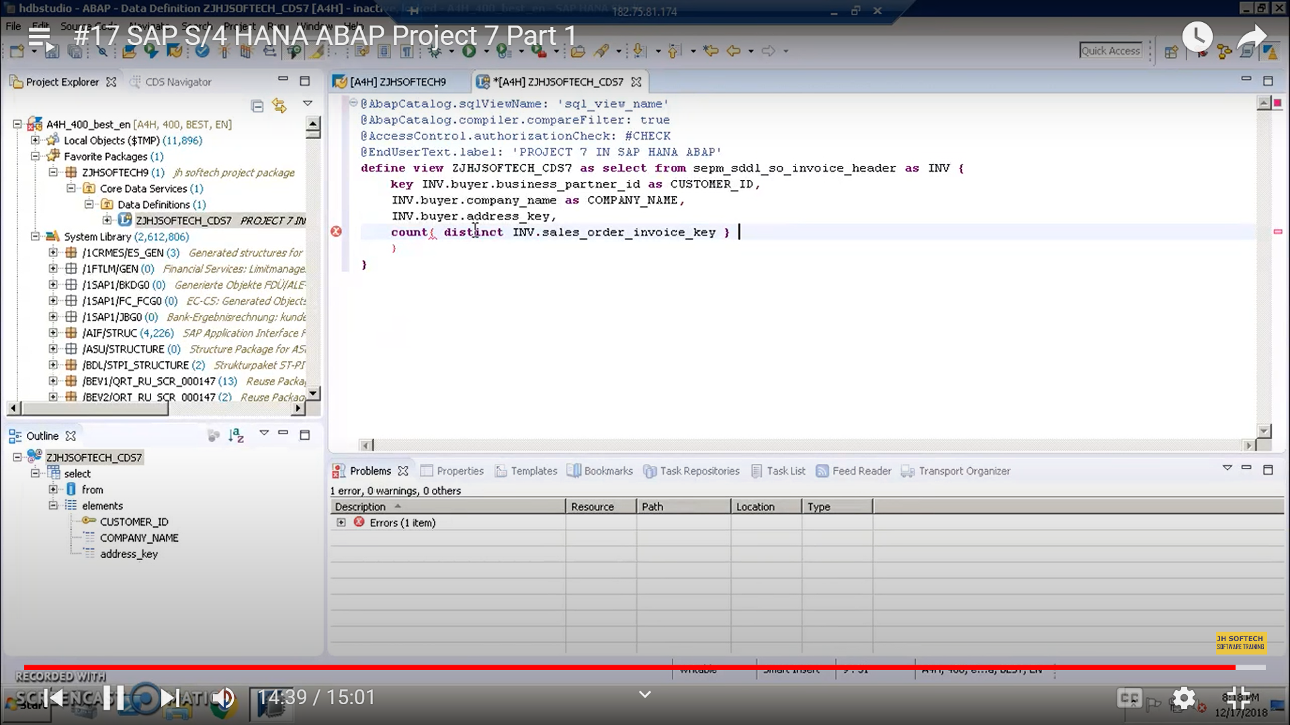

SAP Full Form

ODATA – Open Data Protocol

UI5 - User Interface 5

SAP PO – Process Orchestration

CDS – Core Data Services

NLP - Neuro Linguistic Program

SAP RPA – Robotic Process Automation

SAP RDA – Real Time Data Acquisition

SAP RDS – Rapid Deployment Solutions

SAP SLT – SAP Landscape Transformation Replication Server

EHP – Enhancement Package

S/4 HANA - Suite Fourth Generation High Performance Analytical Appliance

JCO – Java Connector